1. Click on Content management tab. Admin will get all the list.

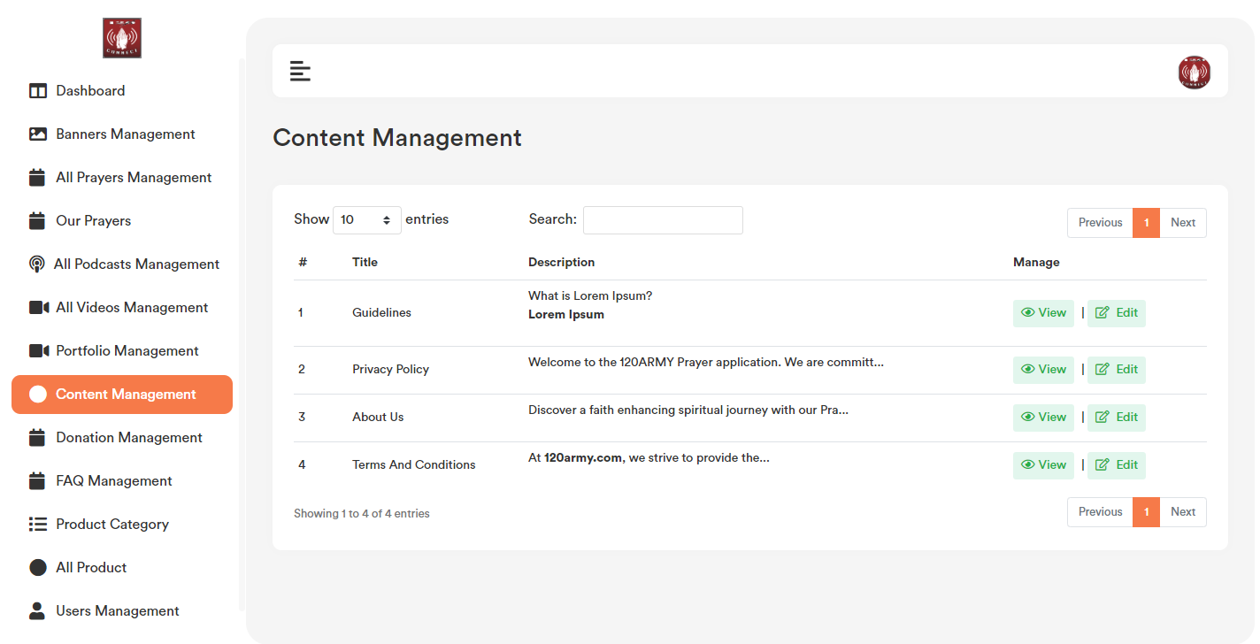

2. Click on the edit option, admin will get a popup with existing data.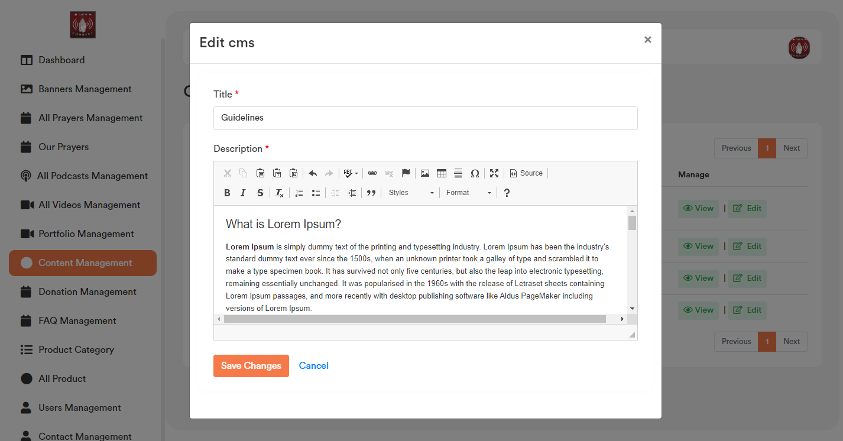

3. In the description text area there is an image option to upload the image in the text area.

4. Click on the image icon admin will get an option on a popup, click on the “upload” tab and select file. After selecting the file click on send it to the server button. Once image upload in the server it will go to the “image info” tab, where admin can change width and height of the image. Once click on ok image will set in the text area. Now click on “Save changes” button for final update of that particular content